Name : Aditi Sant , AI&DS-B1 batch , Roll no.: 23211

**EXPERIMENT NO:13**

#include <iostream>

using namespace std;

const int MAX = 5;

class PizzaParlour

{

int front, rear;

int orders[MAX];

public:

PizzaParlour()

{

front = rear = -1;

}

bool addOrder(int data);

void serveOrder();

void display();

};

bool PizzaParlour::addOrder(int id)

{

if (rear == -1)

{

front = rear = 0;

orders[rear] = id;

return true;

}

else

{

int pos = (rear + 1) % MAX;

if (pos == front)

{

cout << "\nCafe is Full. Please wait.\n";

return false;

}

else

{

rear = pos;

orders[rear] = id;

return true;

}

}

}

void PizzaParlour::serveOrder()

{

if (front == -1)

{

cout << "\nNo Orders in Cafe. (Cafe is Empty)\n";

return;

}

else

{

cout << "\nOrder No. " << orders[front] << " is processed.\n";

if (front == rear) // only one order

{

front = rear = -1;

}

else

{

front = (front + 1) % MAX;

}

}

}

void PizzaParlour::display()

{

int i = 0;

if (front == -1)

{

cout << "\nCafe is Empty. No orders.\n";

return;

}

else

{

cout << "Order Id's : \n";

for (i = front; i != rear; i = ((i + 1) % MAX))

{

cout << orders[i] << " ";

}

cout << orders[rear];

}

}

void intro()

{

char name[50] = {"\n Vaibhav Cafe \n"};

for (int i = 0; name[i] != '\0'; i++)

{

cout << name[i];

}

}

int main()

{

cout<<"Name : Aditi Sant , AI&DS-B1 batch , Roll no.: 23211"<<endl;

int ch, id = 0;

PizzaParlour q;

cout << "\n-----------------";

intro();

cout << "-----------------\n";

do

{

cout << "\n****Menu*****\n";

cout << "1. Accept order\n";

cout << "2. Serve order\n";

cout << "3. Display orders\n";

cout << "4. Exit";

cout << "\nChoice : ";

cin >> ch;

switch (ch)

{

case 1:

id++;

if (q.addOrder(id))

{

cout << "Thank you for order. Order id is : " << id <<endl;

}

else

{

id--;

}

break;

case 2:

q.serveOrder();

break;

case 3:

q.display();

break;

}

} while (ch != 4);

cout << "\nThank You.Keep Visiting.\n\n";

return 0;

}

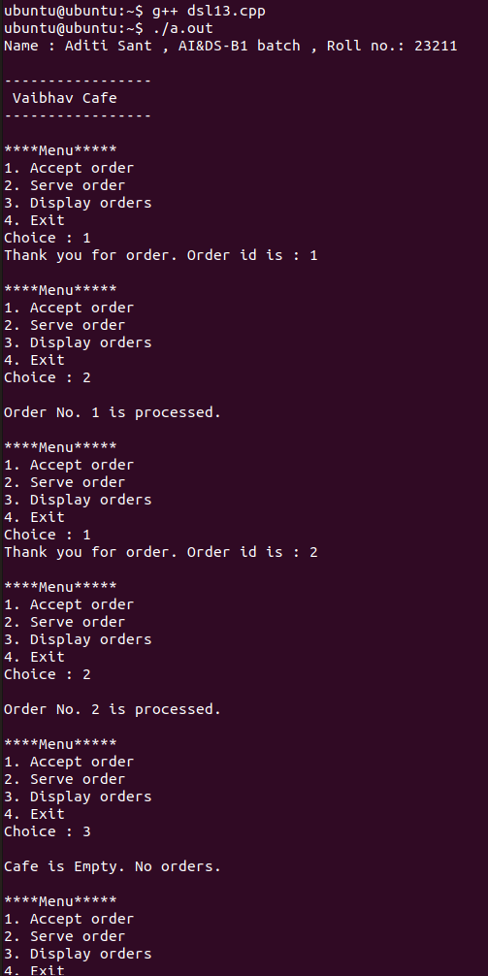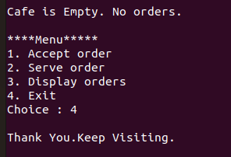**OUTPUT**